Jacob Moody

Oakland City University

CSC V – 1

November 8, 2022

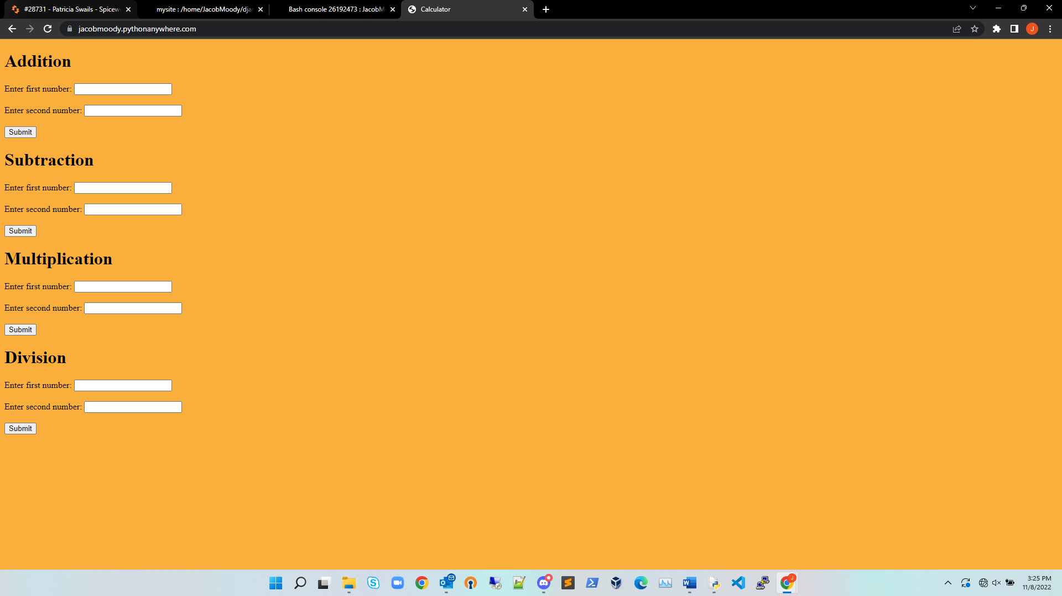

<https://jacobmoody.pythonanywhere.com/>

1. I was not comfortable in how to link the pages around to make sure it grabbed the right thing.
   1. A lot of google searching and reading to better understand how to make sure it found the right area.
2. How to better link pages together and make sure it is reading the right area.
3. It took me several days because I got frustrated and had to stop and not work on it until I felt better about doing the assignment that is why it is late also.
4. That There is still a lot for me to learn and I have a long way to go.